## Exercise 2 – Load Analysis

### Task 1

For the plot plt.ylim was modified to showcase the different voltages since they are all very similar

Lowest voltage is 0.9528 pu at bus 96

### A graph of a voltage Description automatically generatedTask 2

The analysis shows that the grid can support up to an aggregated load of approximately 0.707 MW before the voltage at critical buses drops below the acceptable limit of 0.95 pu. Initially, with a scaling factor of 1, the lowest voltage is 0.9528 pu., which is within the safe range. However, as the load increases, the voltage steadily decreases, and at a scaling factor of 1.5556 (aggregated load 0.707 MW), the voltage reaches 0.9497 pu, just below the threshold. This indicates that the grid's capacity is constrained at this point, and additional load could lead to voltage regulation issues, highlighting the need for flexibility solutions to manage further load growth.

### Task 3

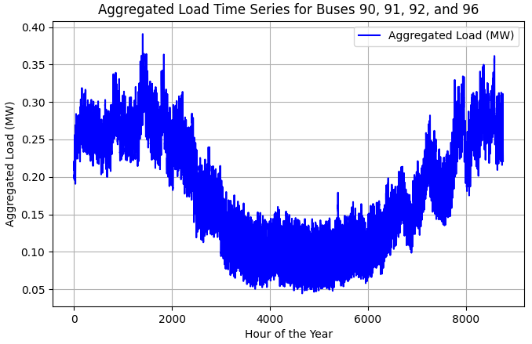

### Task 4

Maximum value of the aggregated load time series: 0.3909 MW

Sum of the maximum load demands (from Task 2): 0.4549 MW (no scaling factor)

The maximum value of the aggregated load time series is lower than the sum of the individual maximum load demands because the peaks at different buses do not occur at the same time. Each bus has a different load profile, and their individual peaks happen at different hours throughout the year. This is typical in distribution networks, where load profiles vary depending on the time of day, season, and consumer behavior. As a result, the aggregate load is "smoothed out" compared to the sum of the individual peak loads.

### A graph with a line Description automatically generatedTask 5

### Task 6

### Total Energy (MWh): 1612.56 MWh

### Maximum Aggregated Load: 0.39 MW

### Utilization Time: 4125.39 hours

### Sum of Individual Maximum Loads: 0.45 MW

Coincidence Factor: 0.86

### A screen shot of a computer program Description automatically generatedTask 7

Capacity Margin: 0.2461 MW

The system can support an additional 0.2461 MW before exceeding the power flow limit.

### Task 8

### Task 9

The system is overloaded by 0.1094 MW after adding the new load

### Task 10

Number of hours with load exceeding the power flow limit (congestion): 19 hours

### Task 11

To alleviate the congestion problem in this grid area, flexibility resources need to be responsive and reliable to manage the peak loads that exceed the power flow limit. Demand response and energy storage systems are highly relevant for addressing this issue by either reducing the load during congestion hours or shifting energy use to off-peak times. Additionally, distributed generation could provide a longer-term solution by reducing the overall demand on the grid.

### Task 12

The Load Duration Curve gives a helpful overview of how electricity demand changes over time, but it has several limitations when used to analyze grid congestion. It does not provide information about when peak loads happen, which is essential for operational decisions. It also hides daily and seasonal load variations, which are important for managing resources like energy storage or demand response programs. Additionally, the LDC does not give insight into how the loads at different points in the grid are related, nor does it clearly show the risks of overloading at specific times.

### Task 13

### Task 14

### Task 15

The need for flexibility resources depends on both the utilization time and coincidence factor:

* A constant new load (Case a) presents the greatest risk of congestion and the most immediate need for flexibility solutions like energy storage, demand response, or distributed generation to manage sustained high load.
* A time-varying new load (Case b) introduces more variability, with peaks occurring at different times, which may call for more dynamic flexibility solutions that can respond to short-term spikes in demand.
* Existing loads only (Case c) present the least risk of congestion, but some flexibility measures may still be needed during peak times to ensure the system operates within limits.